A local fitness center called Forward Fitness Club opened recently and needs a website to help promote its business. The business owner wants the website to showcase the club’s equipment, group fitness classes, nutrition information, and contact information.

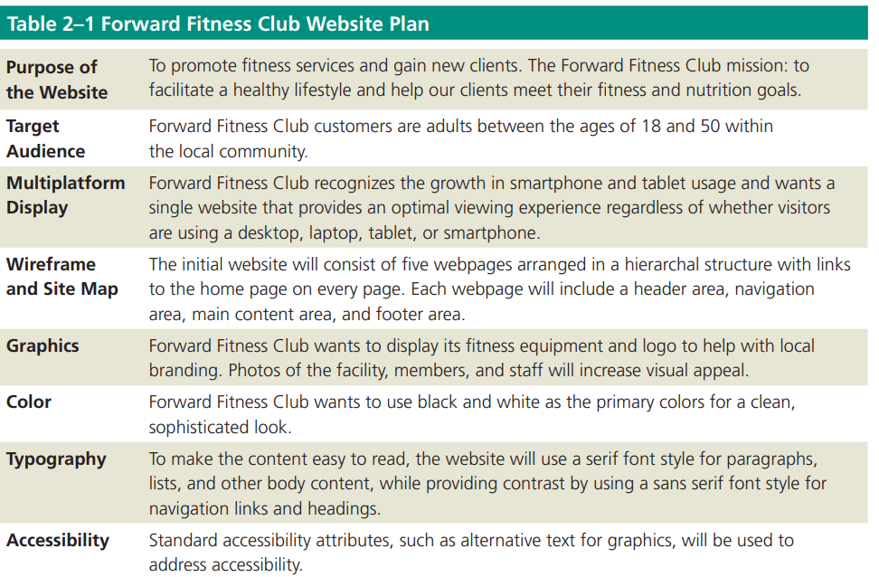**Plan :**

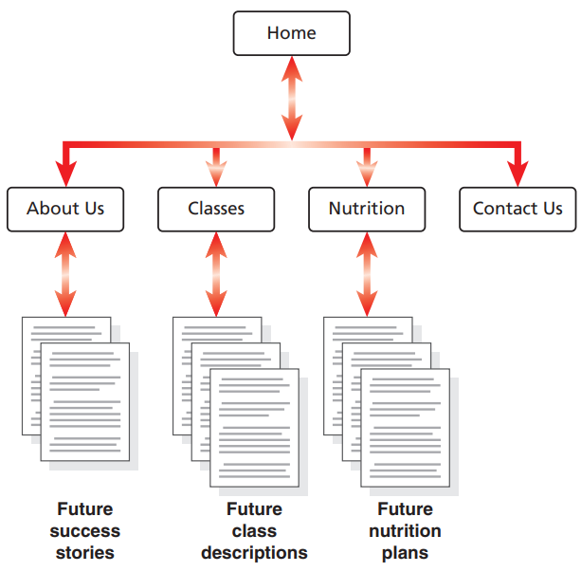**Site map :**

To create a site map, you first need to know how many pages to include in the website. The owner of Forward Fitness Club has many ideas for the website, including some ambitious ones. To keep the website simple for now while allowing room for growth, you and the owner agree that the initial website will have a total of five webpages titled Home, About Us, Classes, Nutrition, and Contact Us. Because each page will contain links to all pages and accommodate future growth, the website will use a modified hierarchal structure. The webpages will include the following content:

• Home page: Introduces the fitness center and its mission statement

• About Us page: Showcases the facility’s equipment and services

• Classes page: Includes a schedule of available group training and fitness classes

• Nutrition page: Provides nutrition tips and simple meal plans

• Contact Us page: Provides a phone number, email address, physical address, and form for potential clients to request additional information about the fitness center’s services

**Wireframe :**

In addition to the site map for the Forward Fitness Club website, you have sketched out a webpage wireframe. Recall that a wireframe depicts the layout of a webpage, including its major content areas. Forward Fitness Club wants to promote its brand by including its logo, so each page will contain a designated area called the header for the logo. The header is located at the top of a webpage and identifies the site, often by displaying the business name or logo. For easy navigation, each page also will have a horizontal list of links to the other pages in the site. These page links will appear below the header in the navigation area. An image banner below the navigation area will display a fitness image. The primary page content, or the main content area, will follow the image banner and will contain information that applies to the page, including headings, paragraphs of text, and images. Lastly, the footer will be located below the primary page content and will contain copyright and contact information. Figure 2–3 shows the proposed wireframe with these major content areas.